AWS Key Management Service KMS
1. AWS Key Management Service (KMS)
1.1 Overview
AWS KMS is a managed service that enables you to create, manage, and control cryptographic keys used to encrypt data across AWS services and applications.

1.2 Use Cases
• Encrypt data at rest for S3, EBS, RDS, DynamoDB, EFS
• Encrypt sensitive environment variables in Lambda
• Customer-managed keys (CMKs) for compliance (PCI-DSS, HIPAA, ISO)
• Envelope encryption for application-level data
• Centralized key management and auditing
• Cross-account encryption

1.3 Architecture Flow
- User/Application requests data encryption
- AWS service calls AWS KMS
- KMS uses a Customer Managed Key (CMK) or AWS Managed Key
- KMS returns an encrypted data key
- Data is encrypted and stored securely
- All key usage is logged in AWS CloudTrail
Application → AWS Service → AWS KMS → Encrypted Data Stored

1.4 Execution Steps
Step 1: Create a KMS Key
- Go to AWS Console → KMS
- Click Create key
- Select Symmetric key
- Choose Encrypt and decrypt
- Add alias (example: alias/app-key)
- Assign key administrators and users

Step 2: Define Key Policy
• Allow IAM roles/services to use the key
• Grant least-privilege access
Example policy snippet:
{
"Effect": "Allow",
"Principal": {"Service": "ec2.amazonaws.com"},
"Action": ["kms:Encrypt", "kms:Decrypt"],
"Resource": "*"
}

Step 3: Encrypt a Resource
• Enable encryption using the KMS key in:
- S3 bucket
- EBS volume
- RDS instance

Step 4: Audit and Monitor
• Enable CloudTrail
• Monitor key usage and access
• Rotate keys automatically
1.5 Best Practices
• Use Customer Managed Keys for sensitive workloads
• Enable automatic rotation wherever possible
• Grant least-privilege IAM permissions
• Never hardcode secrets
• Monitor usage with CloudTrail and CloudWatch
• Separate secrets per environment (dev, staging, prod)
1.6 Conclusion
AWS KMS provide a strong security foundation for encryption, credential management, compliance, and secure application design in AWS environments.

- TASKS ON KEY MANAGEMENT SERVICE KMS
Task 1: Encrypt an S3 Bucket Using AWS KMS (CMK)
Objective
Secure S3 data at rest using a Customer Managed KMS Key.
Prerequisites
• AWS Account
• S3 Bucket
• KMS permissions
Execution Steps
Step 1: Create KMS Key
- Go to AWS Console → KMS
- Click Create key
- Select Symmetric
- Usage: Encrypt and decrypt
- Alias: s3-encryption-key
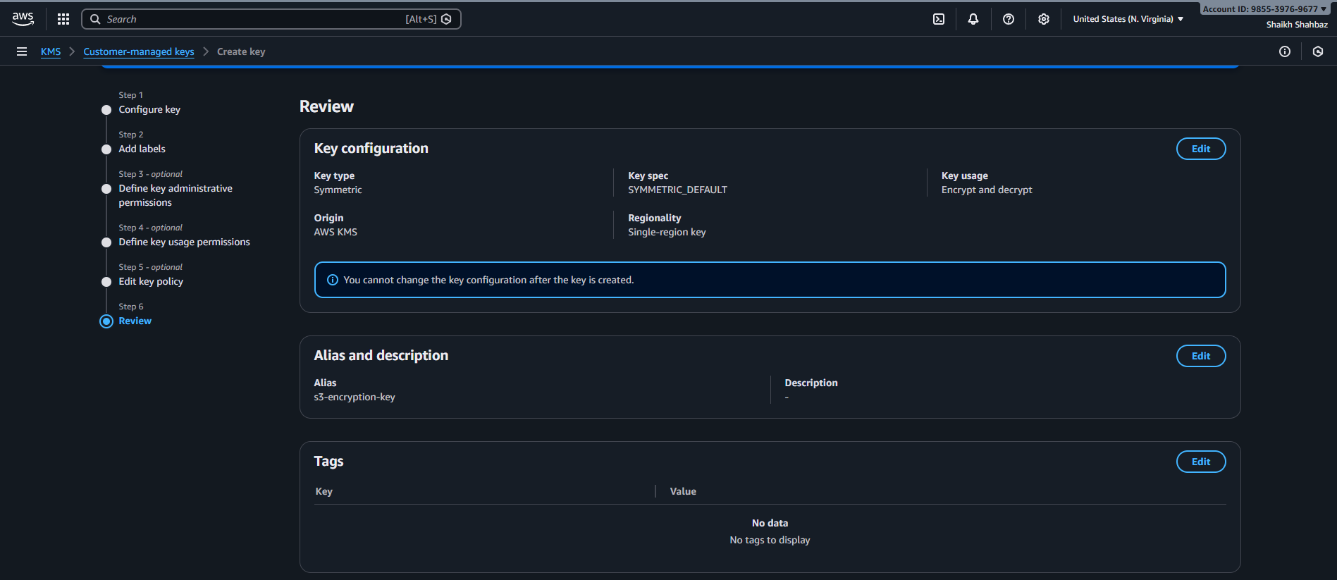
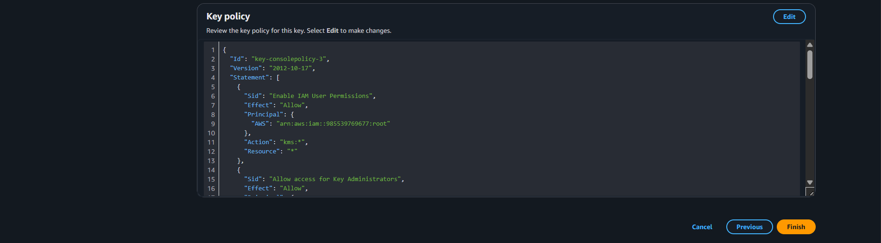
Step 2: Assign Permissions
- Add IAM users/roles as key users
- Save key
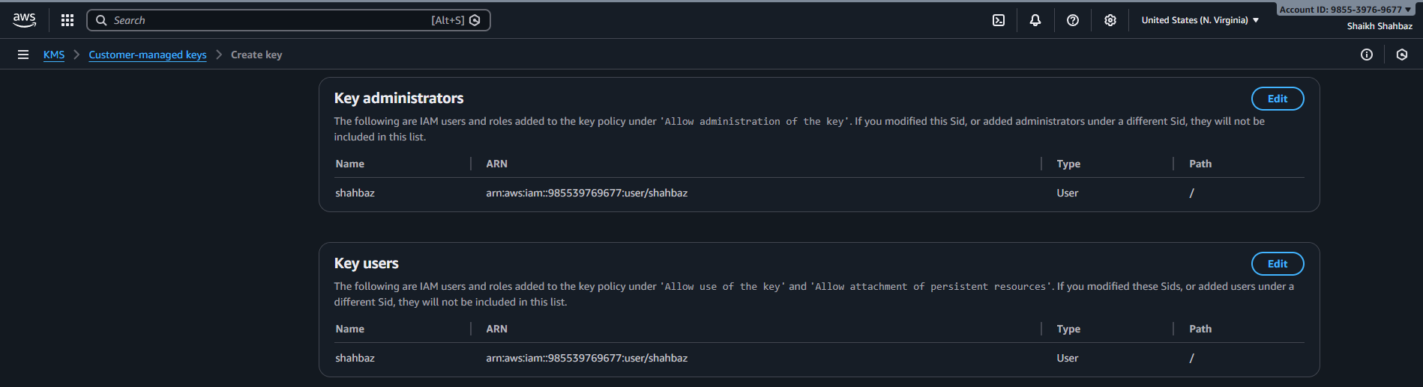
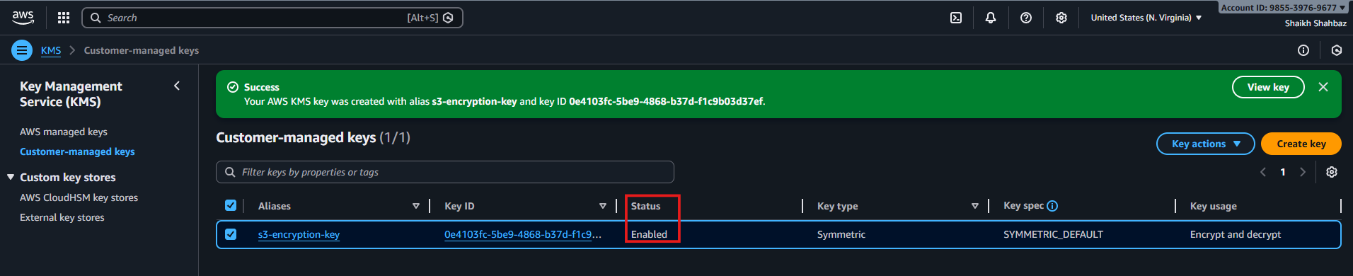
Step 3: Enable S3 Encryption
- Go to S3 → Bucket
- Open Properties
- Enable Default encryption
- Select AWS KMS
- Choose alias/s3-encryption-key
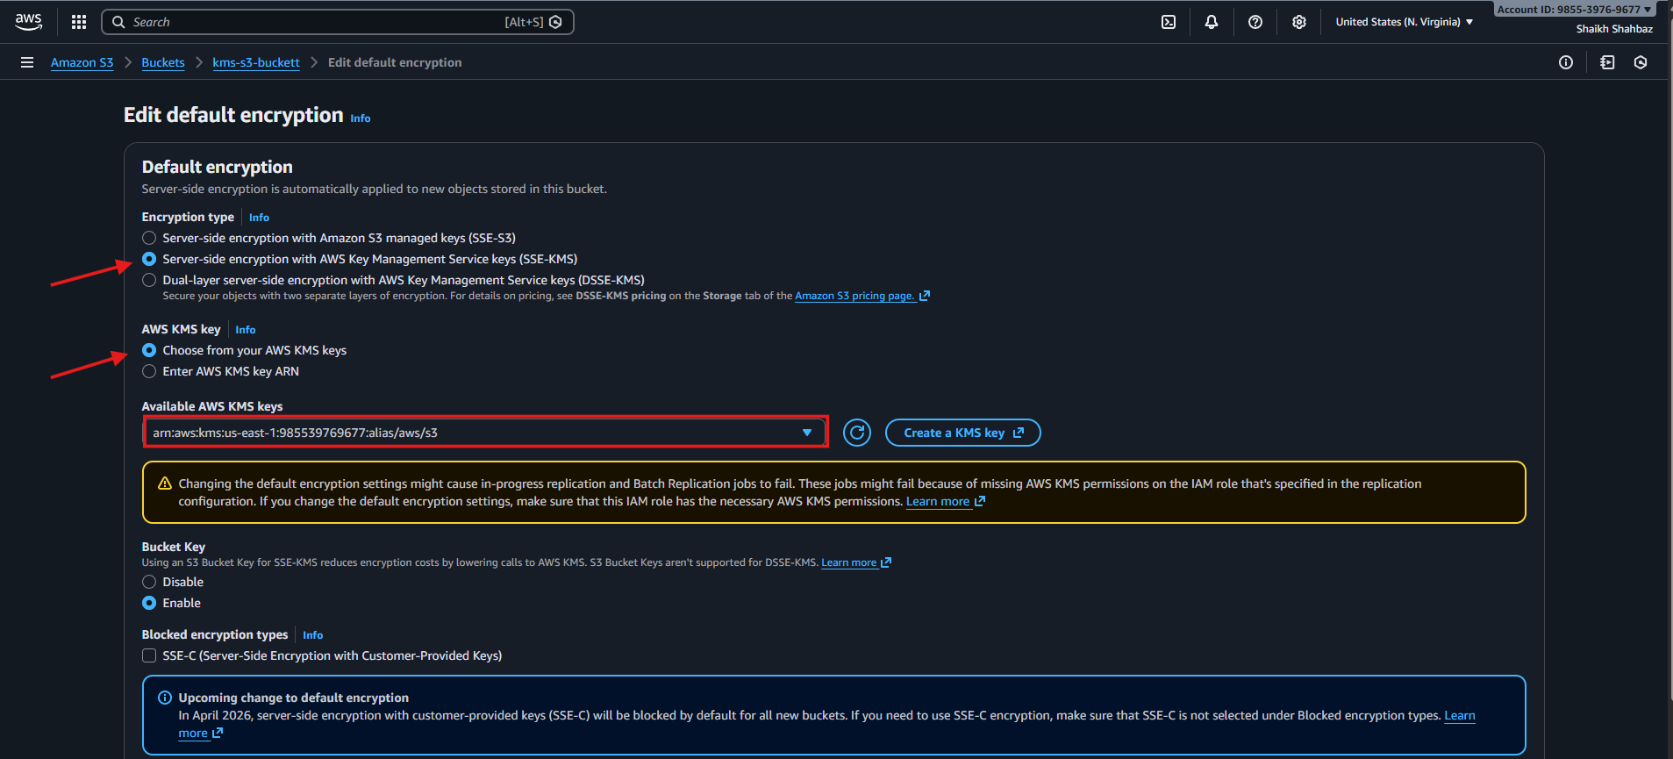
Step 4: Validate
• Upload a file
• Confirm encryption = aws:kms
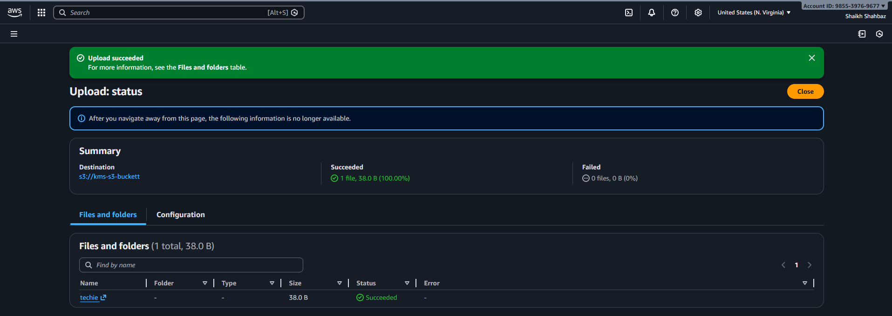
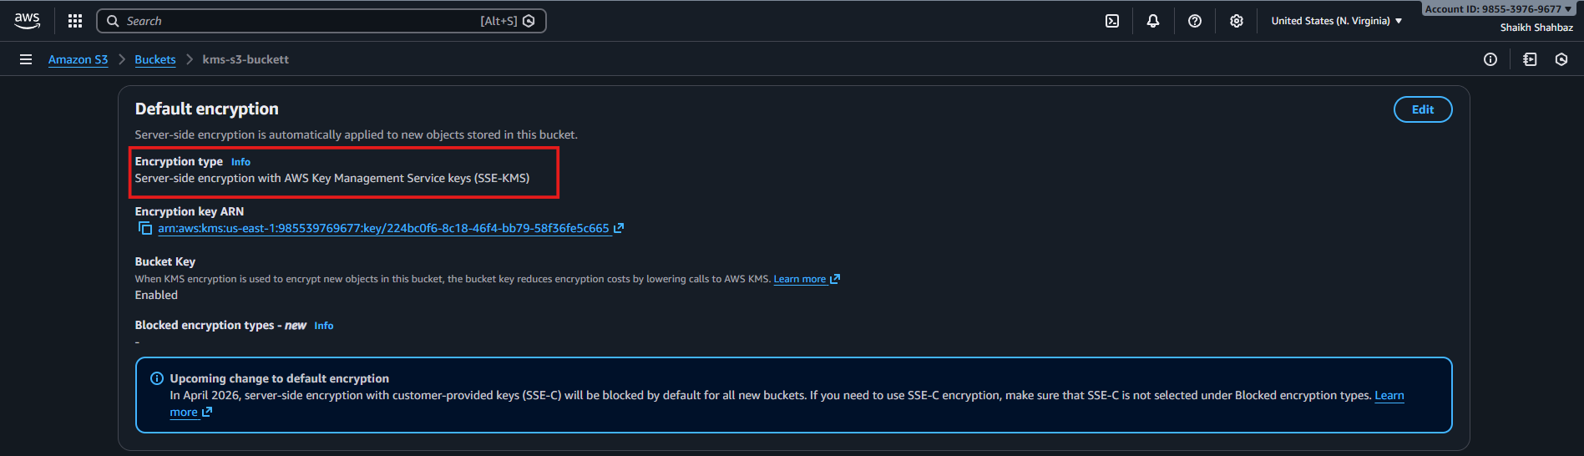
Conclusion:
Encrypting an S3 bucket with a customer-managed KMS key ensures data at rest is protected with full control over key usage and access. This enhances security, auditing, and compliance by centralizing encryption management in AWS KMS.

Task 2: Encrypt an EBS Volume Using KMS
Objective
Protect EC2 disk data using KMS-encrypted EBS volumes.
Prerequisites
• EC2 Instance
• KMS Key
• IAM Role
Execution Steps
Step 1: Create KMS Key
• Same steps as Task 1
• Alias: ebs-key
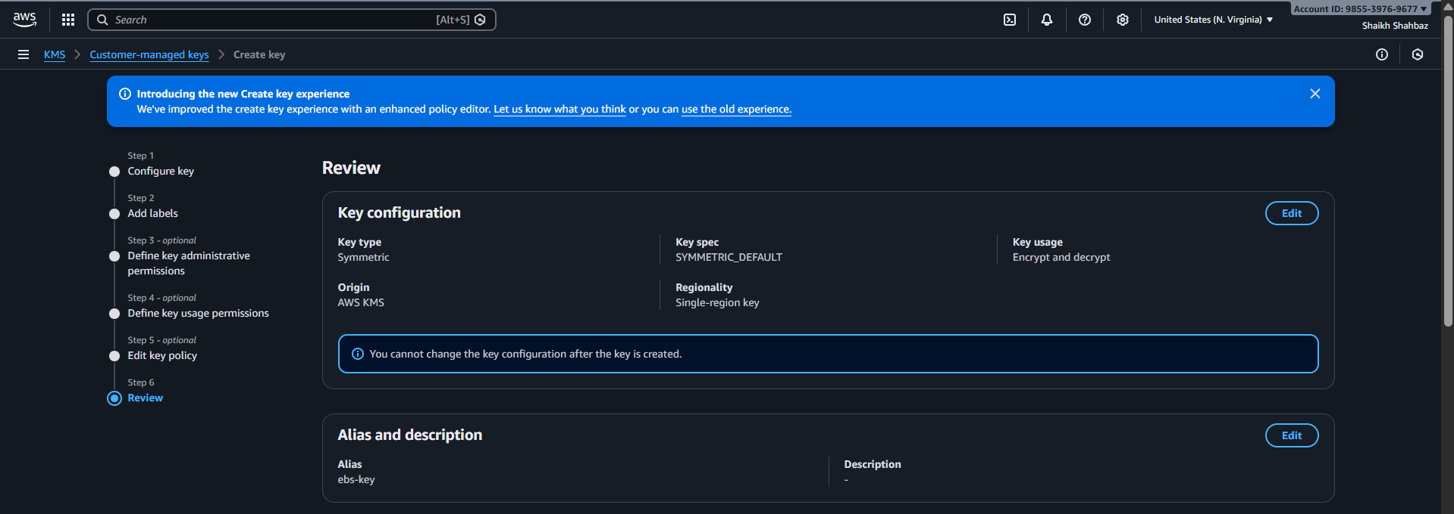
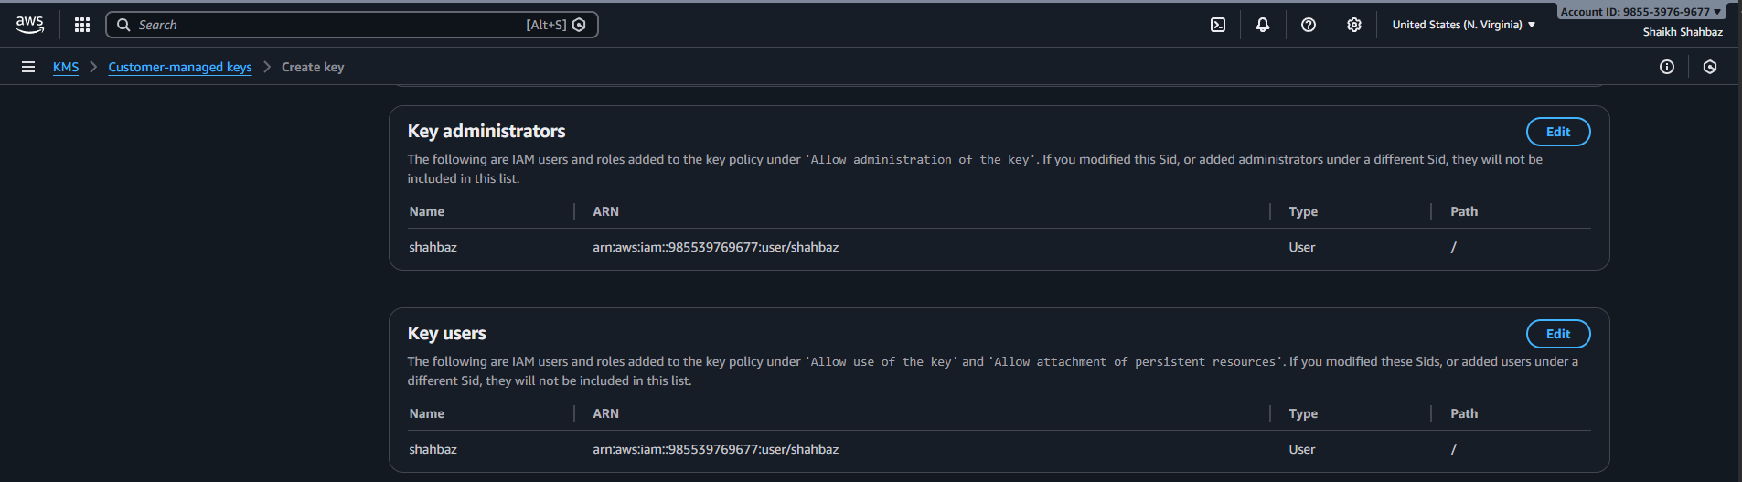
Step 2: Create Encrypted EBS Volume
- Go to EC2 → Volumes
- Click Create volume
- Enable Encryption
- Select KMS key ebs-key
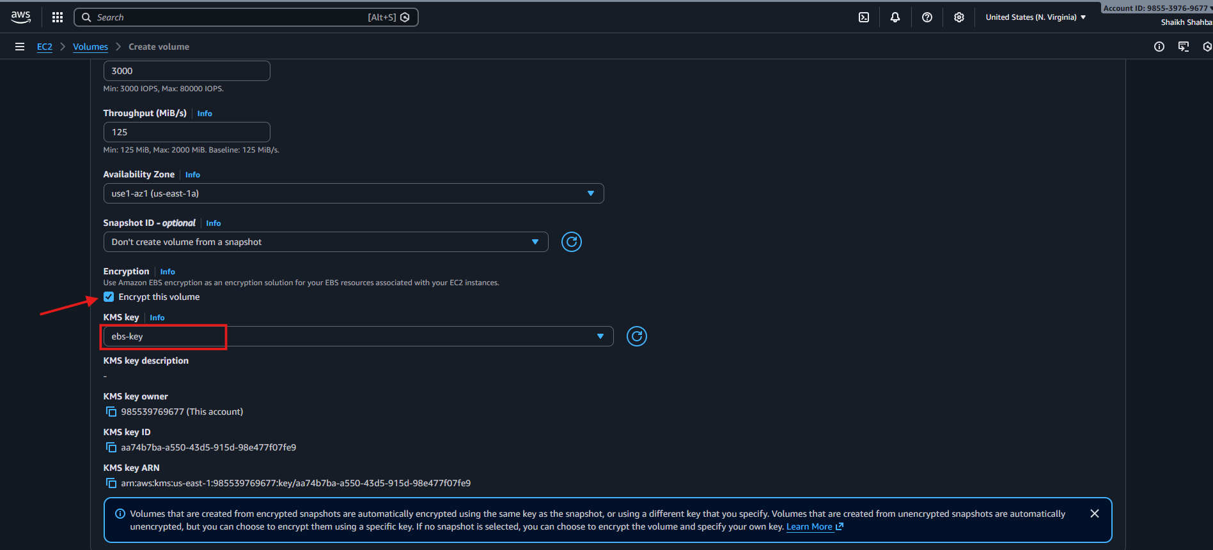
Step 3: Attach Volume
- Attach volume to EC2 instance
- Mount volume inside instance
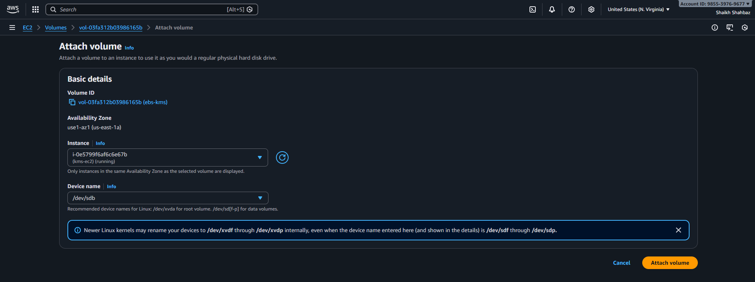
Step 4: Verify
• Check volume → Encryption = Enabled
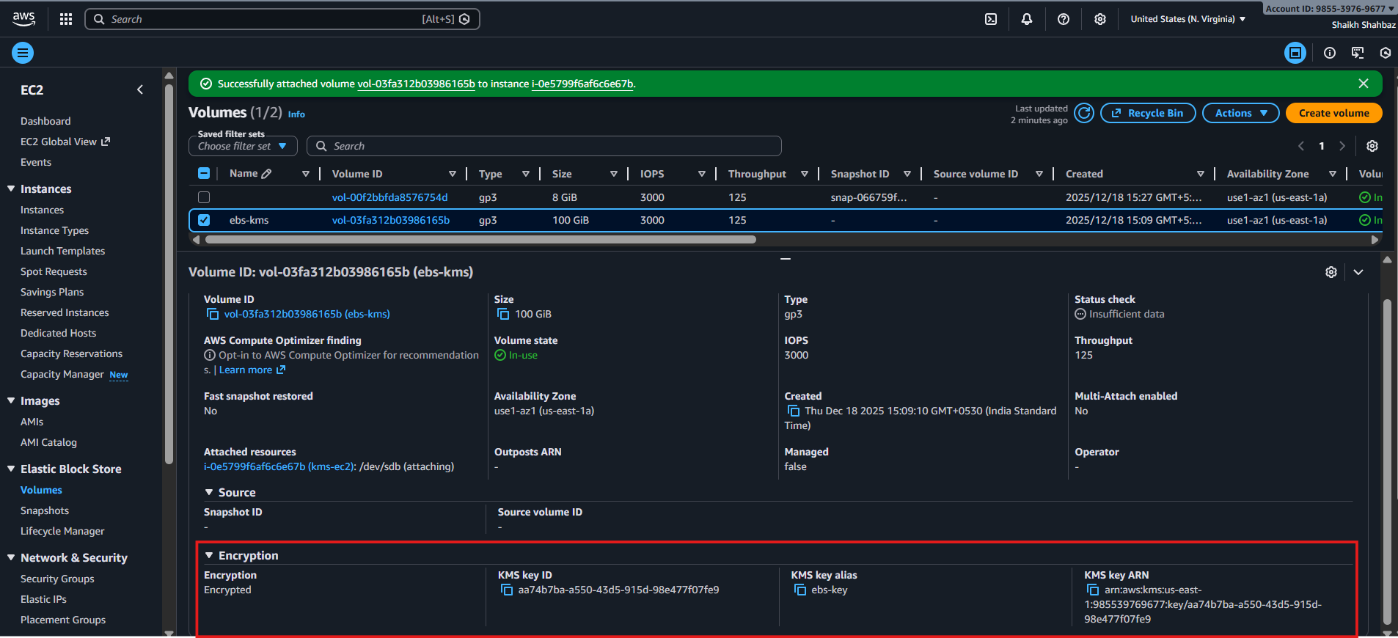
Conclusion:
Encrypting an EBS volume with AWS KMS protects all data stored on the volume at rest using strong encryption. It provides secure key management, auditing, and seamless integration with EC2 without impacting application performance.

Task 3: Encrypt Lambda Environment Variables Using KMS
Objective
Secure sensitive Lambda variables using KMS.
Prerequisites
• Lambda Function
• KMS Key
Execution Steps
Step 1: Create KMS Key
• Alias: lambda-env-key
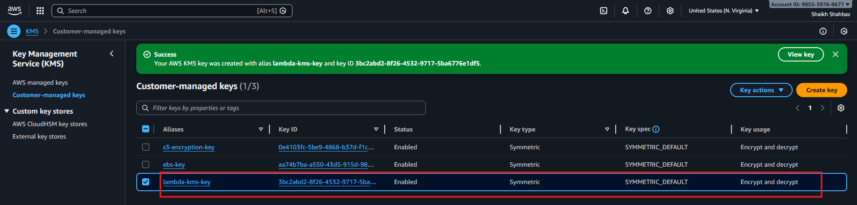
Step 2: Update Lambda
- Go to Lambda → Configuration
- Open Environment variables
- Add sensitive values (API keys)
- Choose Encryption key
- Select KMS key
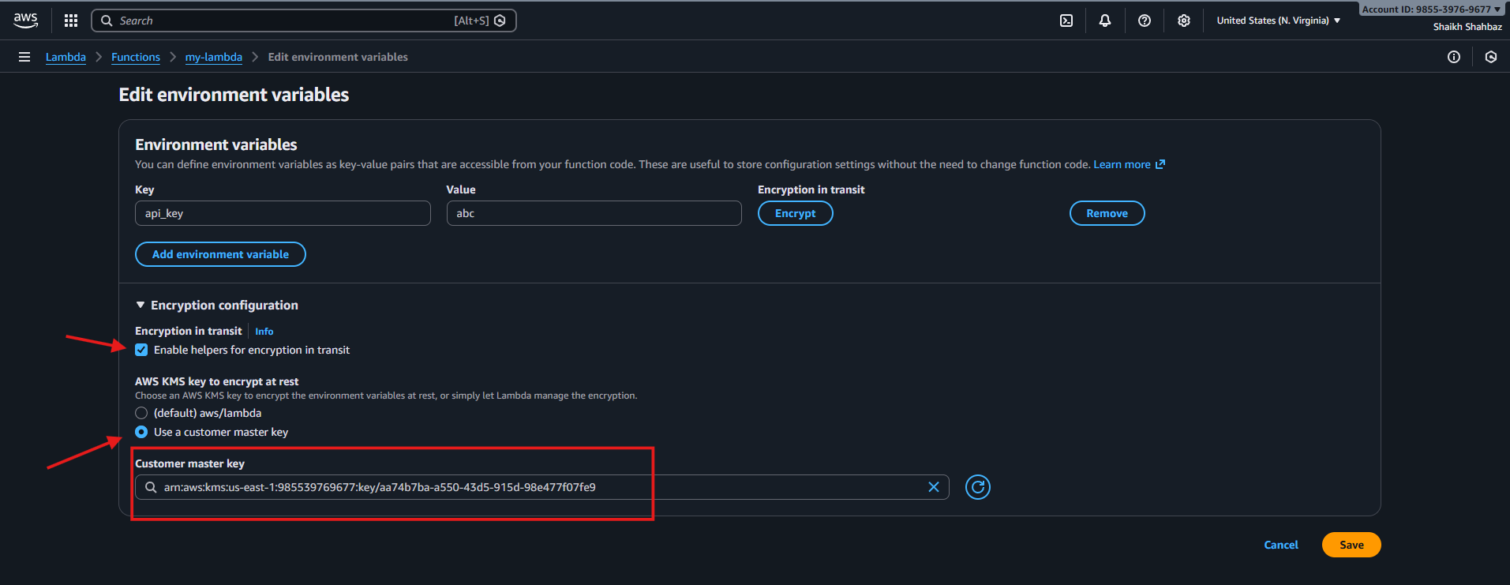
Step 3: Grant Permissions
• Add kms:Decrypt permission to Lambda role
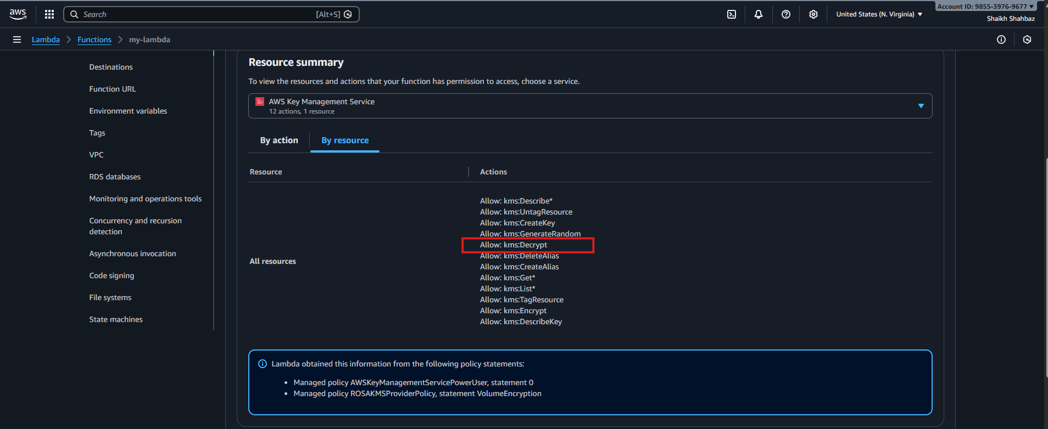
Step 4: Test Lambda
• Ensure function executes successfully
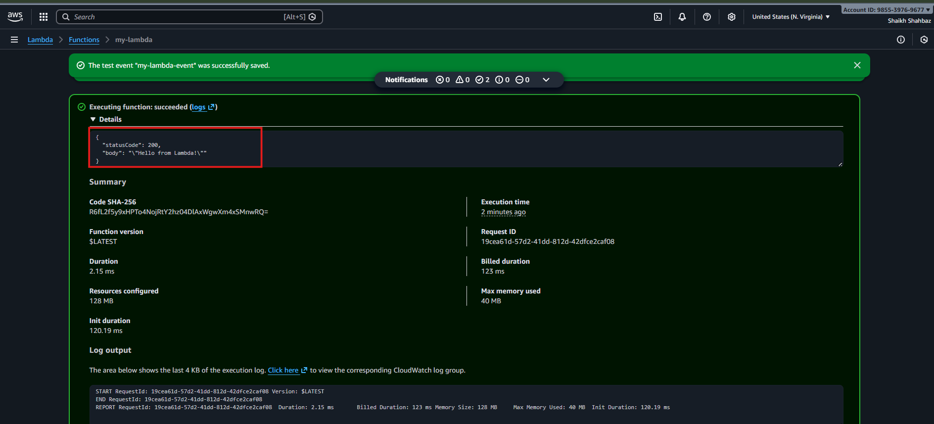
Conclusion:
Encrypting Lambda environment variables with KMS protects sensitive information from unauthorized access and ensures compliance with best practices for data security.

